# Dairy Delights



**Session 2023 - 2027**

**Submitted by:**

Abu Tayyab 2023-CS-54

**Supervised by:**

Prof. Maida Shahid

**Course:**

CSC-103 Object Oriented Programming

Department of Computer Science

**University of Engineering and Technology****Lahore Pakistan**

CSC-102 Programming Fundamentals Dairy Delights

Table of Contents

Dairy Delights 1

1. Introduction: 4

Design 4

OOP Pillars 4

2. User Roles and Functionalities: 4

I) Admin: 4

ii) Worker 5

iii) Delivery Boy: 5

iv) Customer: 5

3. Wire Frames: 7

4. CRC 23

5. Complete Code: 24

6. Weakness in Project: 45

7. Future Directions 45

Table of Wire frames

Figure 1Sign Up Page 7

Figure 2Sign In page 8

Figure 3Admin Main Page 8

Figure 4Add User Admin 9

Figure 5Remove User 9

Figure 6orders 10

Figure 7Add Product 10

Figure 8Remove Products 11

Figure 9Update Products 11

Figure 10Check Reviews 11

Figure 11Check complains 12

Figure 12Update Worker 12

Figure 13Update Delivery Boy 13

Figure 14Change Password 13

Figure 15pending Orders Worker 14

Figure 16Worker Main Menu 14

Figure 17Add Complains 15

Figure 18view and Delete Complains 15

Figure 19Update Customer 16

Figure 20View details Worker 16

Figure 21Delivery Boy Main Menu 17

Figure 22View Product details in Order 17

Figure 23Deliver Order 18

Figure 24View Details Delivery Boy 18

Figure 25Customer Main Page 19

Figure 26View Products Available for Sale 19

Figure 27View Reviews about Product 20

Figure 28View Product Details 20

Figure 29Give Review 21

Figure 30View Cart 21

Figure 31Buy Cart 22

Figure 32View undelivered Orders 22

Figure 33Update Customer Details 23

Figure 34CRC 23

# 1. Introduction:

Dairy Delights Business Application is designed to manage operations for a dairy products business. This application provides functionalities for four types of users: Admin, Employees, Delivery Boy and Customers. The application offers a user-friendly interface allowing efficient management of tasks related to inventory, sales, and customer interactions.

# Design

The whole project consists of 3 sub-projects:

1. **Project Library:** It contains all the classes of the entities in the Business Layer and a Data Layer to manage all entities’ data. The Data Base folder in the Data Layer handles all data using Database connection and SQL queries. Likewise, The File Handling folder handles only the User data. The Data Layer Interfaces folder contains all the Interfaces of the Data Layer Classes. The use of C# language is in full effect in the back-end. This Library makes the base of the Application.
2. **Window Forms Project:** It contains the Front-End of the Application. User-Friendly Window Forms are linked with the Project Library for smooth running of the Application.
3. **Console Application:** It contains a Console App in which the CRUD of the User entity has been performed.

# OOP Pillars

1. **Encapsulation:** The Class Attributes have been made private and accessed through Getters & Setters. The Class Behaviors are public. The Parent Class Attributes are protected.
2. **Association:** The Customer Class has a Ticket Object to show Aggregation between Customer and Ticket classes so that when a customer buys a ticket, it is saved as an object in the customer class. The Ticket Class has an Object of Match class to show which match the ticket is of.

# 2. User Roles and Functionalities:

Dairy Delights supports four user roles: Admin, Employees, Delivery Boy and Customers. Each role has distinct functionalities tailored to their specific needs.

# I) Admin:

1. Add new User to the system.
2. Remove User from the system.
3. View Orders
4. Add More Products
5. Remove Product
6. Update Products
7. Check Review about Products from Customers
8. See Complains/ Suggestions from Worker.
9. Update Details About Worker.
10. Change Password

# ii) Worker

1. Add Products
2. Remove Products
3. Update Products
4. Check Reviews about Products
5. View Pending Orders
6. Write Complains / Suggestions to Admin
7. Update Details of Customer
8. View his details
9. Change Password

# iii) Delivery Boy:

1. View Pending Orders
2. View Order Details
3. Deliver Orders
4. View Personal Details
5. Change Password

# iv) Customer:

1. View Products
2. View Details of Products
3. View Reviews of Products
4. Give Reviews
5. View Own Cart
6. Add Items in Cart
7. Edit Cart
8. Buy Cart
9. View Orders.

(10) Change Password

|  |  |  |
| --- | --- | --- |
| **As a** | **I want to perform** | **So that I can** |
| Admin | Add new employee. | Add a new employee to the system. |
| Remove employee. | Remove employee from the system. |
| View Orders | See All The orders delivered or not |
| Add Product | Add Product in the store |
| Update Product | Update details quantity etc. |
| Remove Products | Remove Products from Inventory |
| Check Review | Check Reviews of Products |
| See complains | See suggestion and problems of Worker |
| Update Users | Update details of Users |
| Change password. | Can change password of any username without even knowing old passwords. |
| Worker | Update Products | Update details of product |
| Add products | Add new products for sale in inventory. |
| Remove products | Remove products form the inventory |
| View Orders | View Pending Orders |
| Check Reviews About Products | Check Reviews form Customers. |
| Remove discount. | Remove discount form the products. |
| Update Customer | Change details of Customer |
| Writes complain to Admin. | Writes the issues he is facing to the admin so that issues can be resolved. |
| Change password. | He can change password but cannot change password of employee. |
| Delivery Boy | View Orders | View Order from the Customers |
| Products Details | See products Details in Order |
| Deliver Orders | Deliver orders to the Customer |
| View His Own Details | See his details Bike number etc. |
| Change Password | Change his own password |
| Customer | View products. | See products available for sale. |
| View Reviews | See review of other Customers |
| View Details | View the description and other details about products |
| Give Feedback | Give review about products |
| View Cart | View His Items |
| Edit Cart | Change the cart add or remove things |
| Buy | Buy the products |
| Change password | Change login password |
| Update Details | Update Address and phone number etc. |

# Wire Frames:

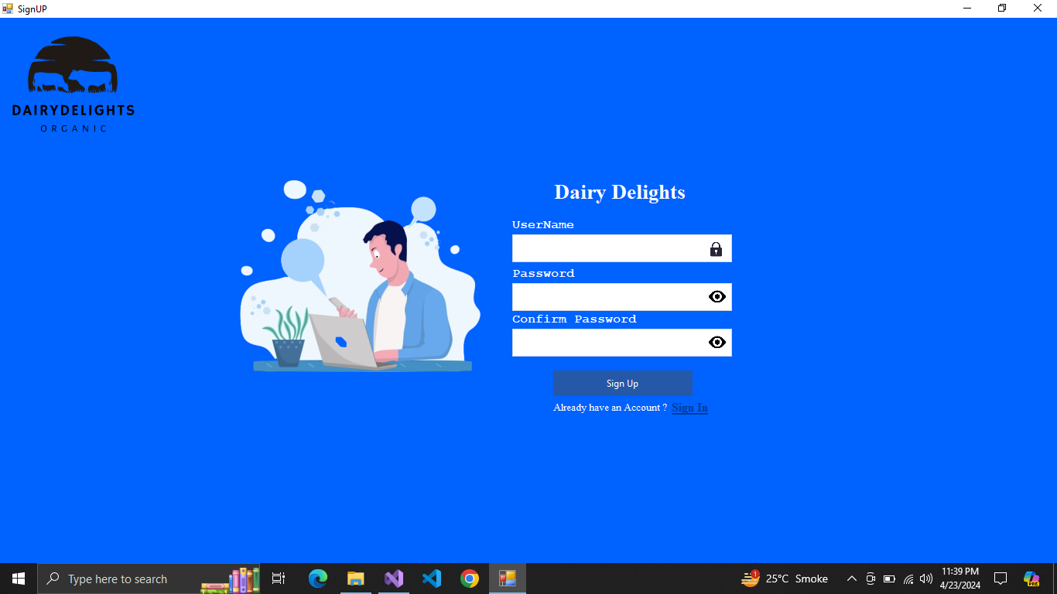

**Figure 1Sign Up Page**

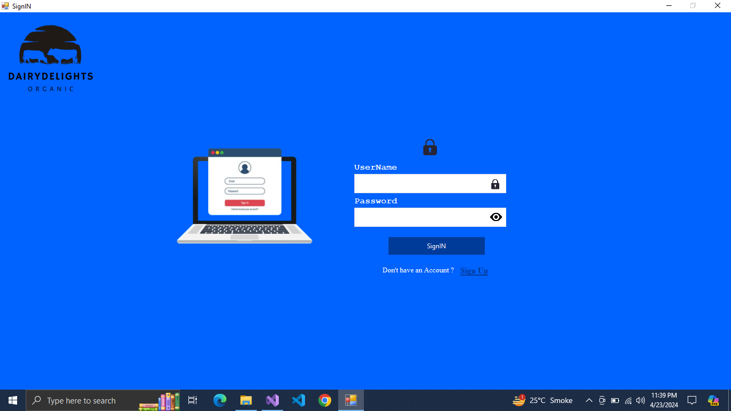

**Figure 2Sign In page**

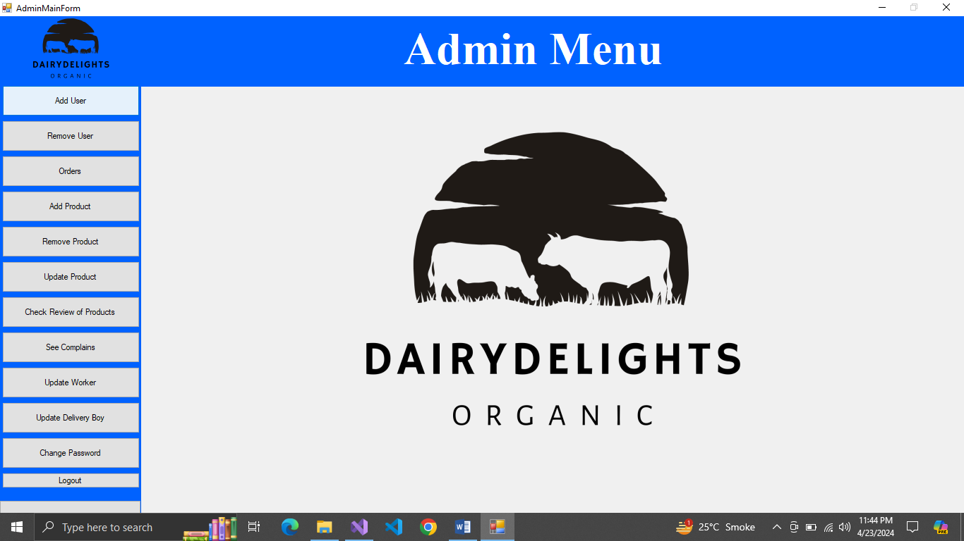

**Figure 3Admin Main Page**

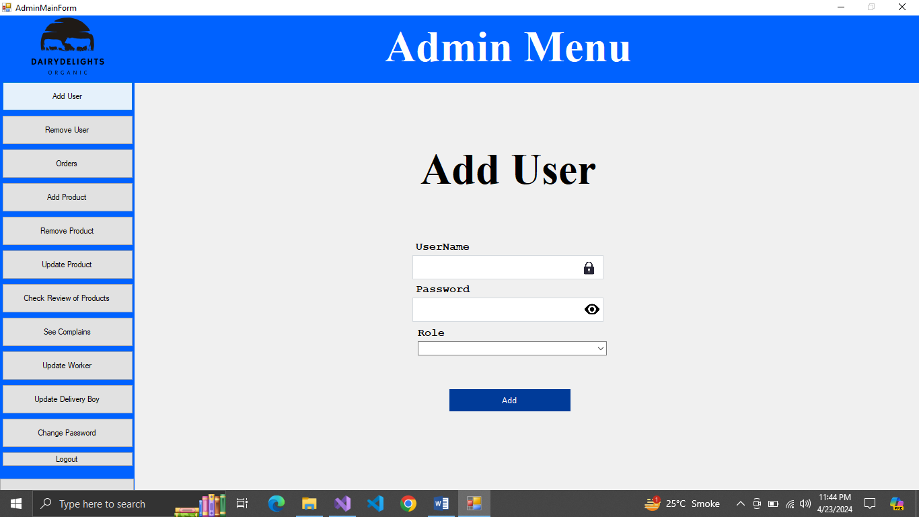

**Figure 4Add User Admin**

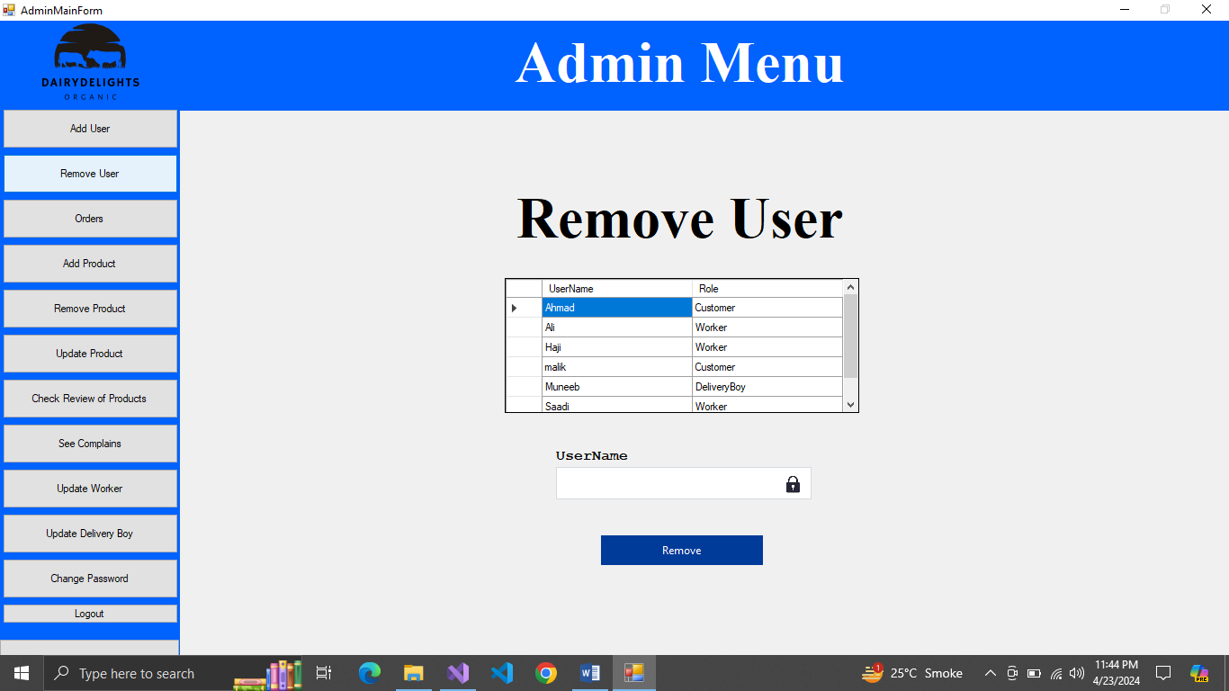

**Figure 5Remove User**

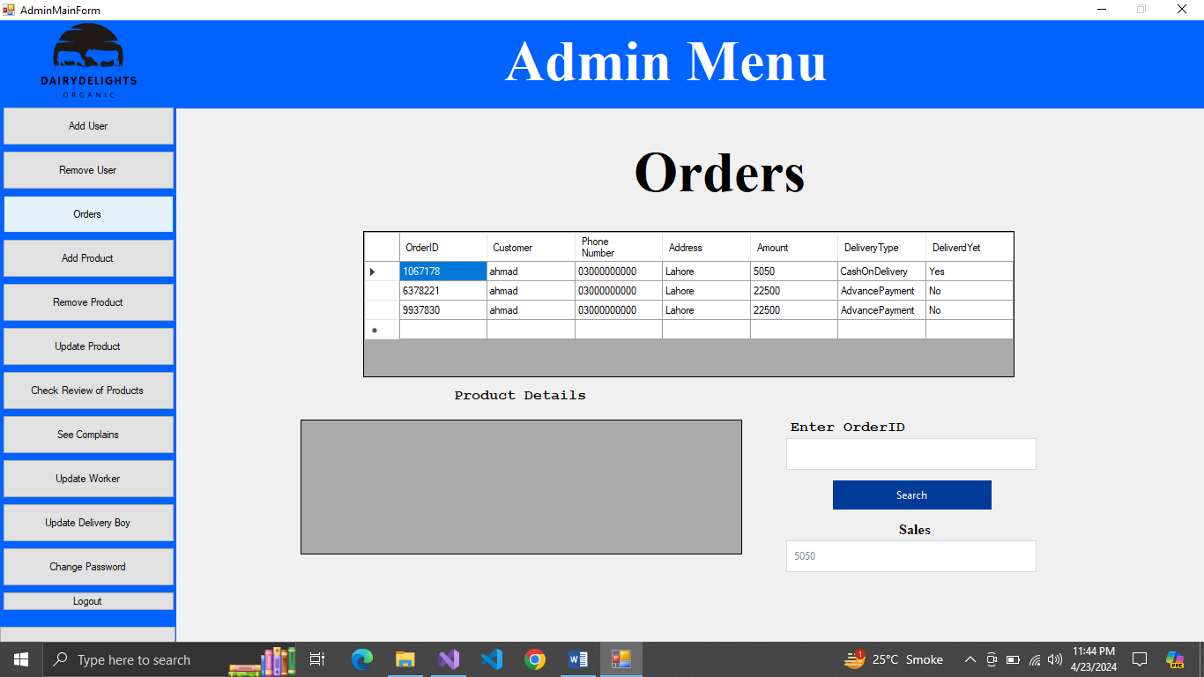

**Figure 6orders**

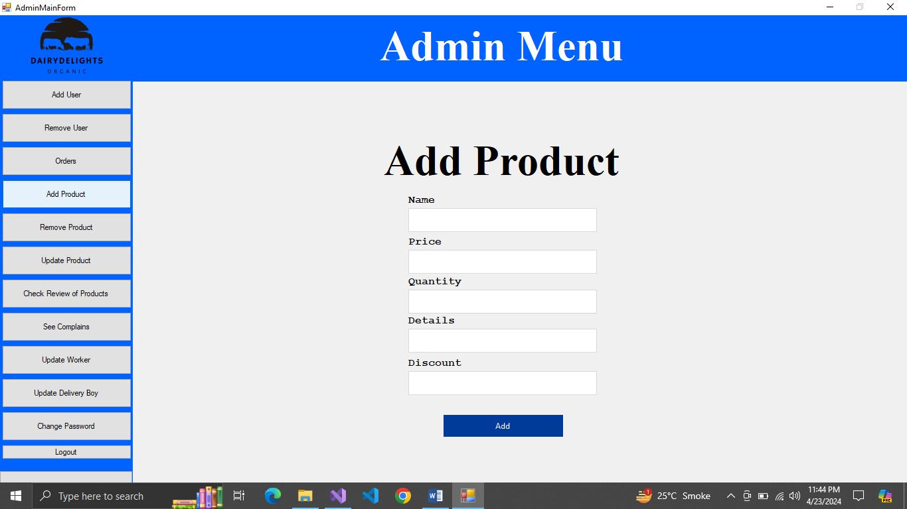

**Figure 7Add Product**

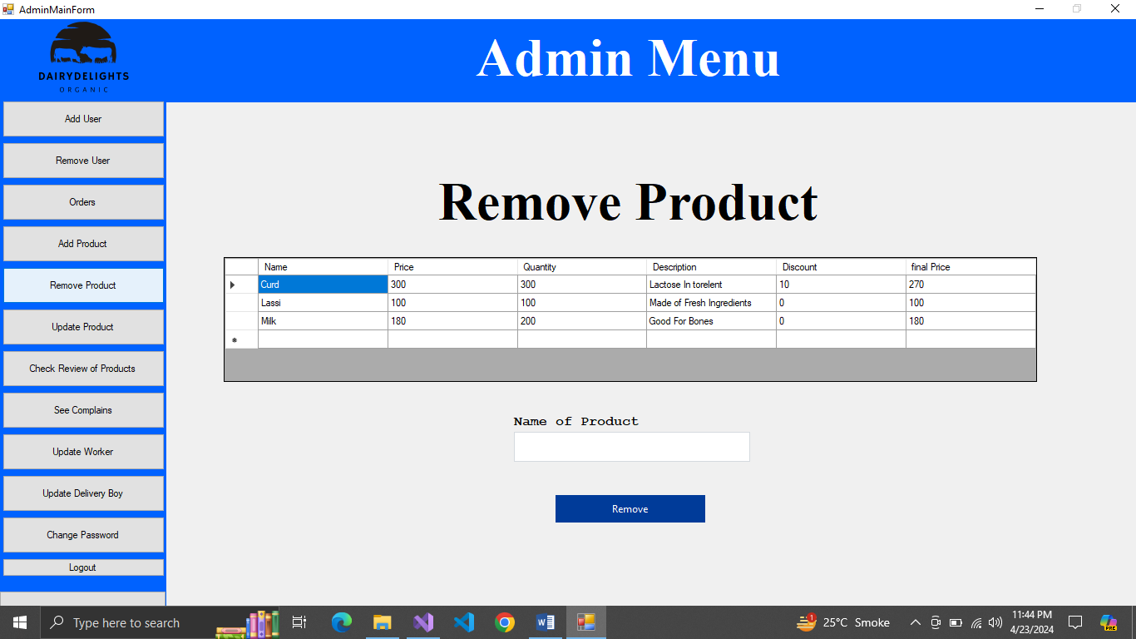

**Figure 8Remove Products**

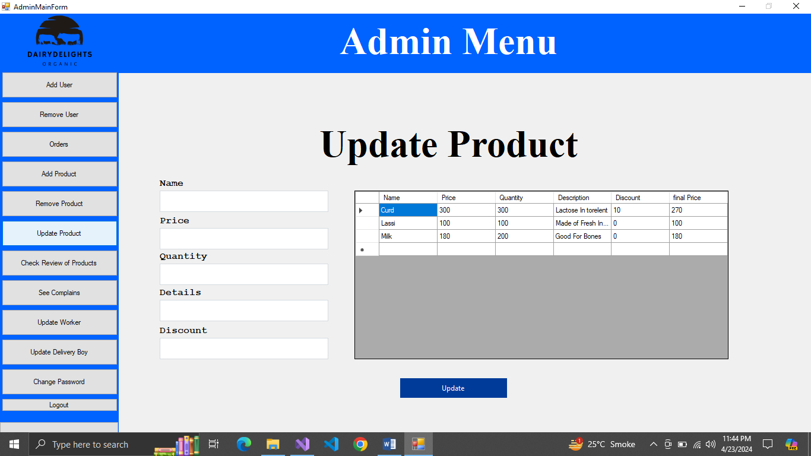

**Figure 9Update Products**

**Figure 10Check Reviews**

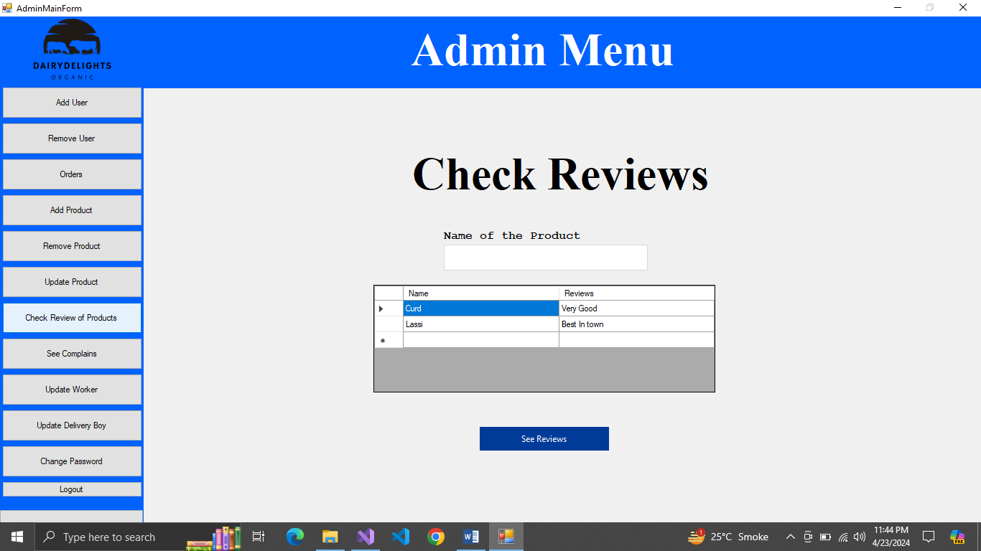

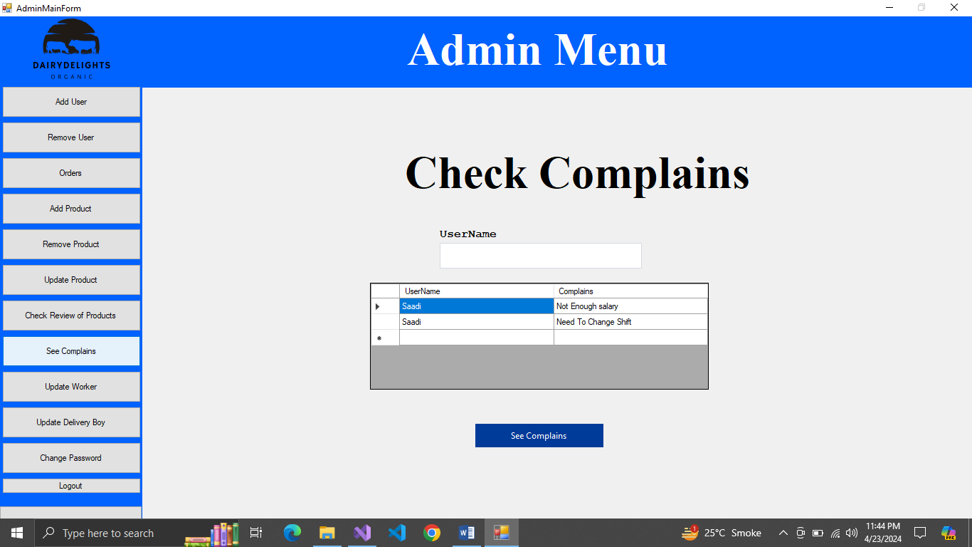

**Figure 11Check complains**

**Figure 12Update Worker**

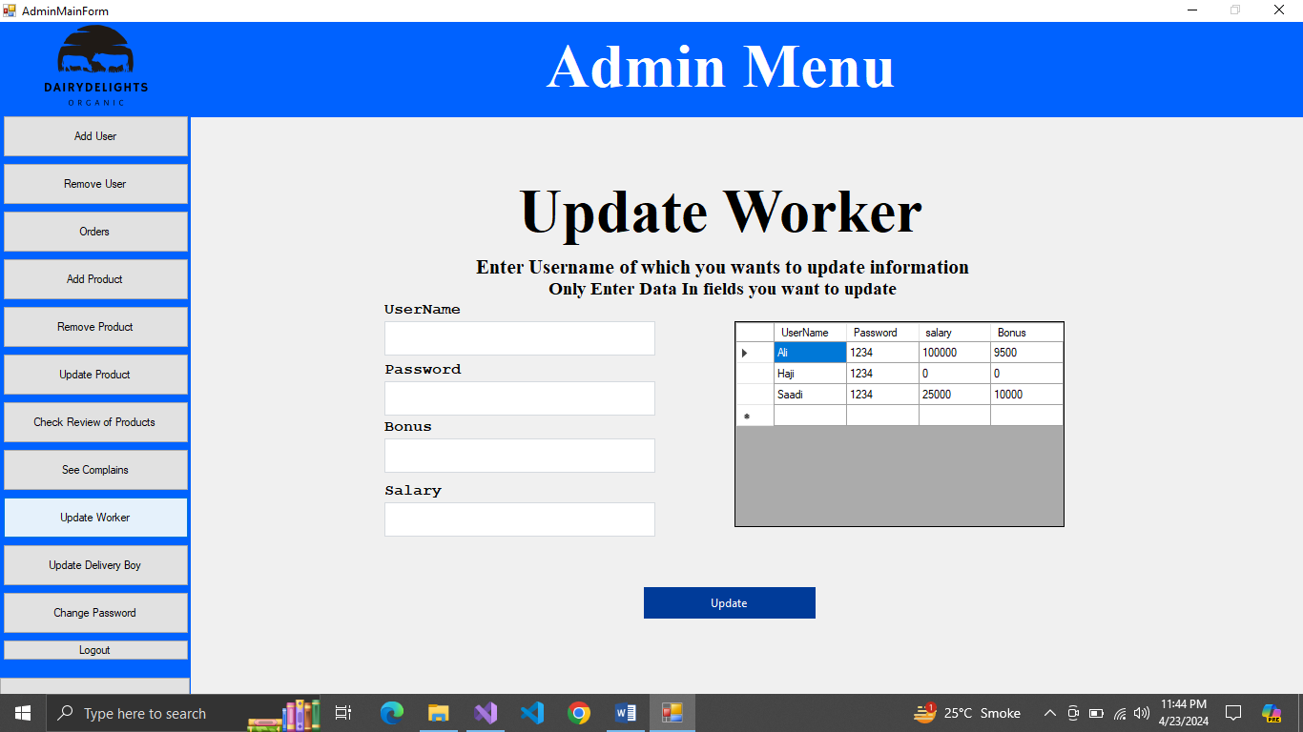

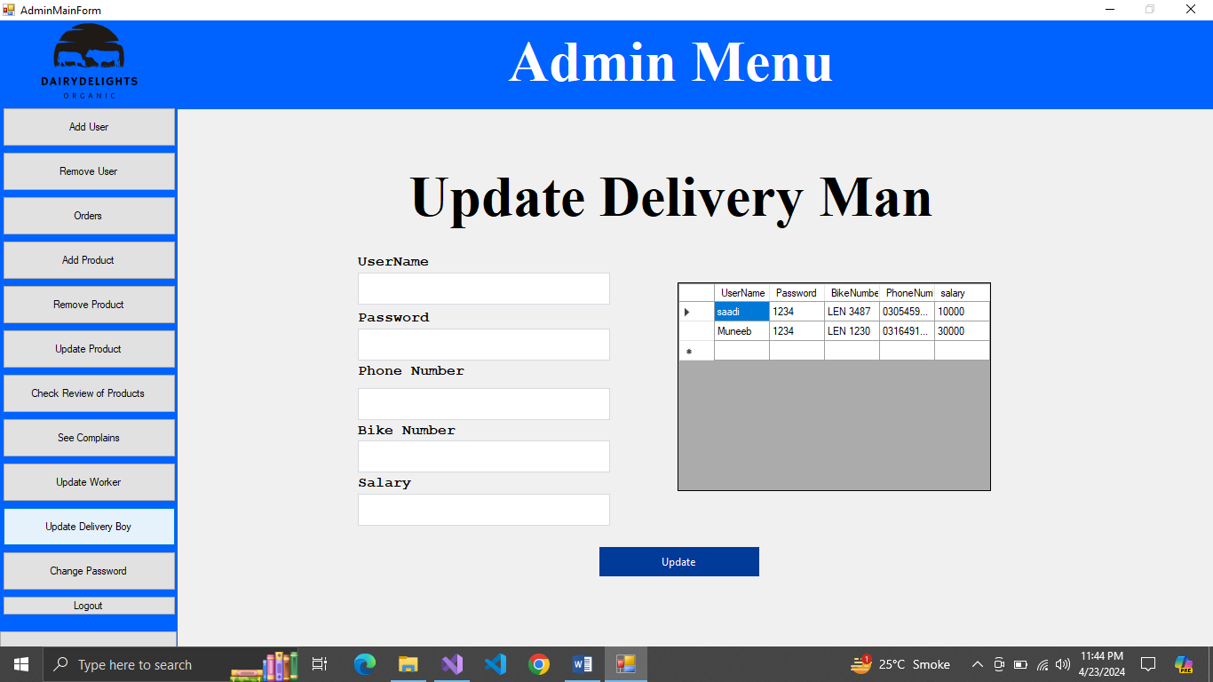

**Figure 13Update Delivery Boy**

**Figure 14Change Password**

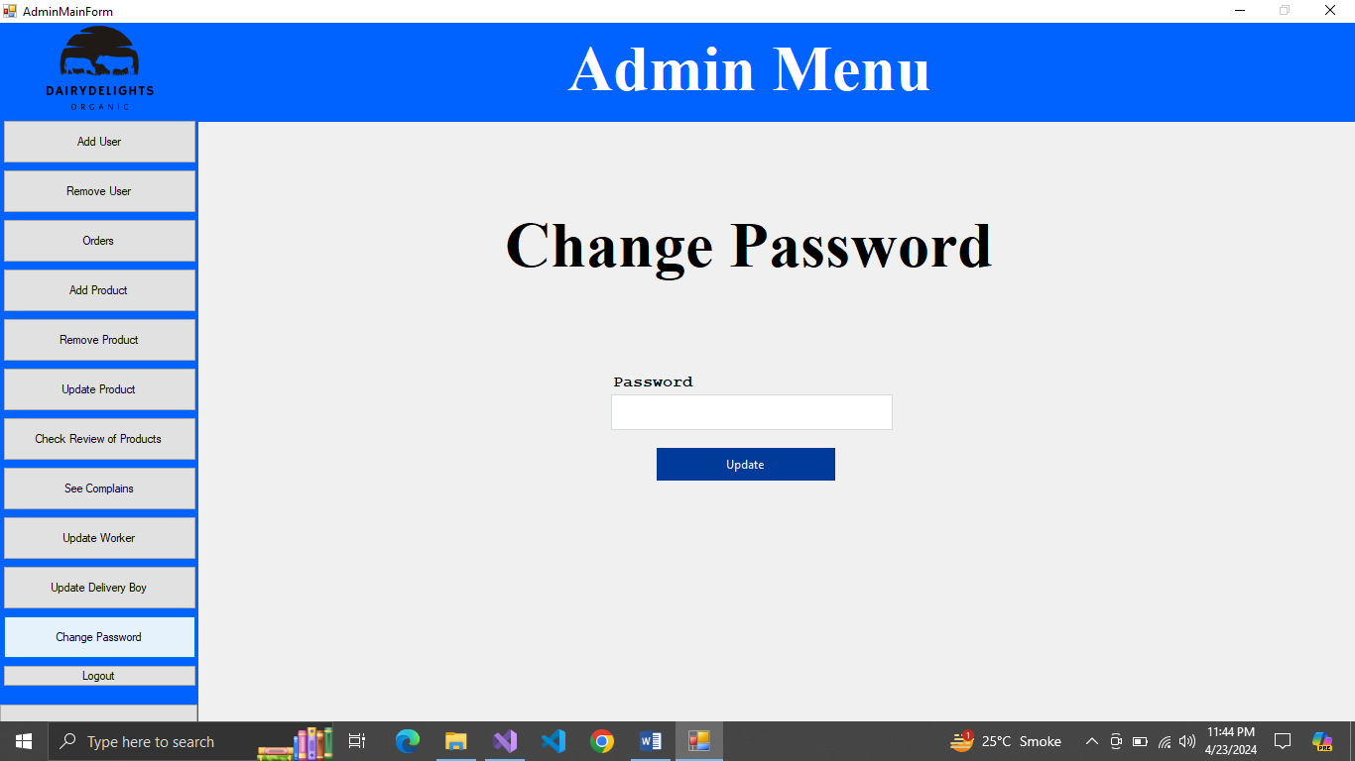

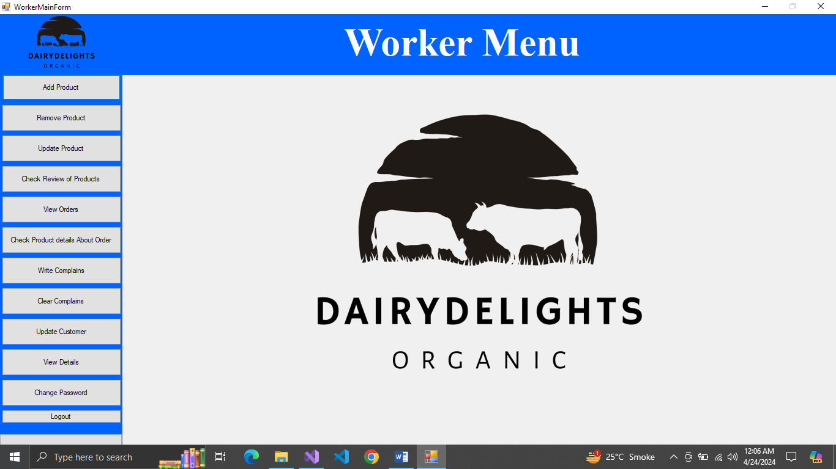

Figure 15pending Orders Worker

Figure 16Worker Main Menu

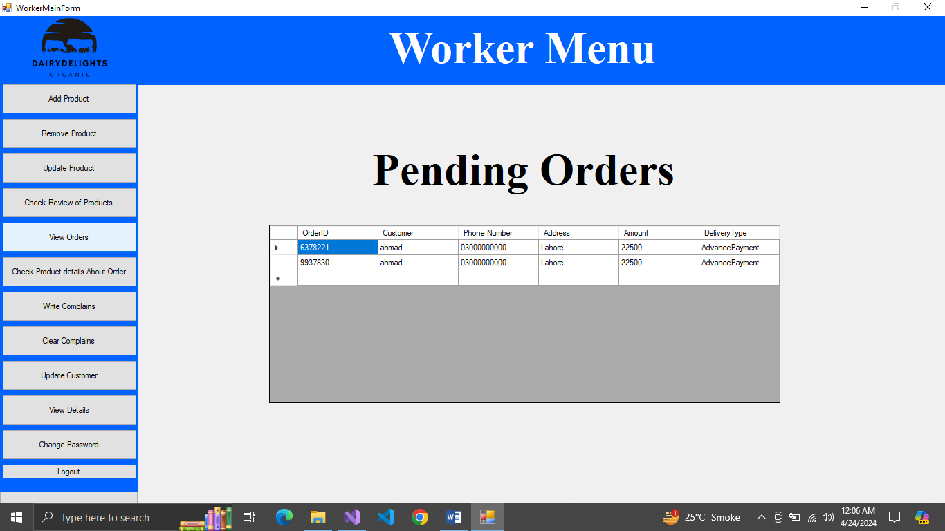

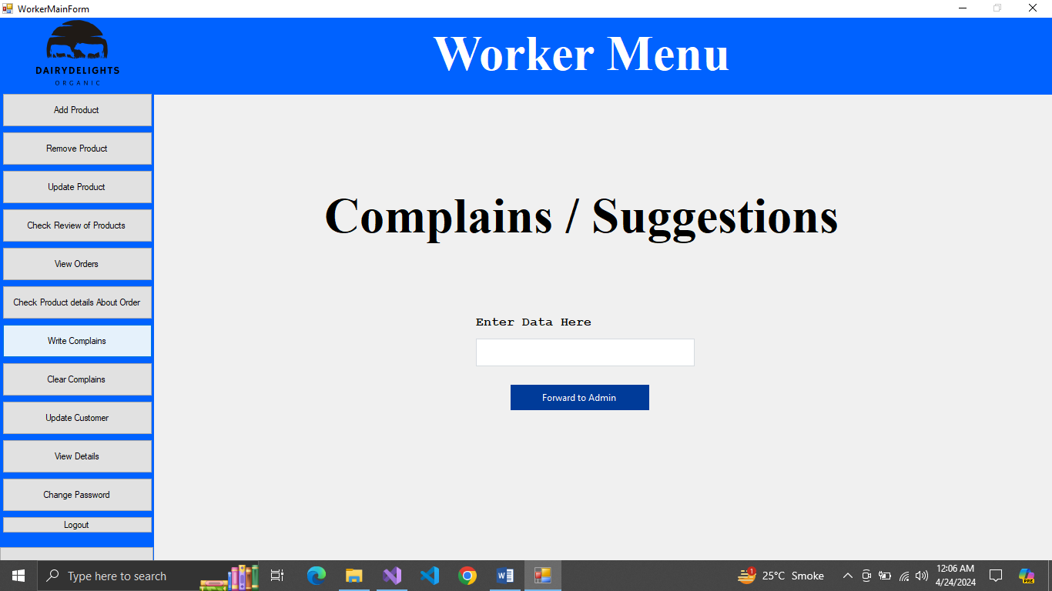

Figure 17Add Complains

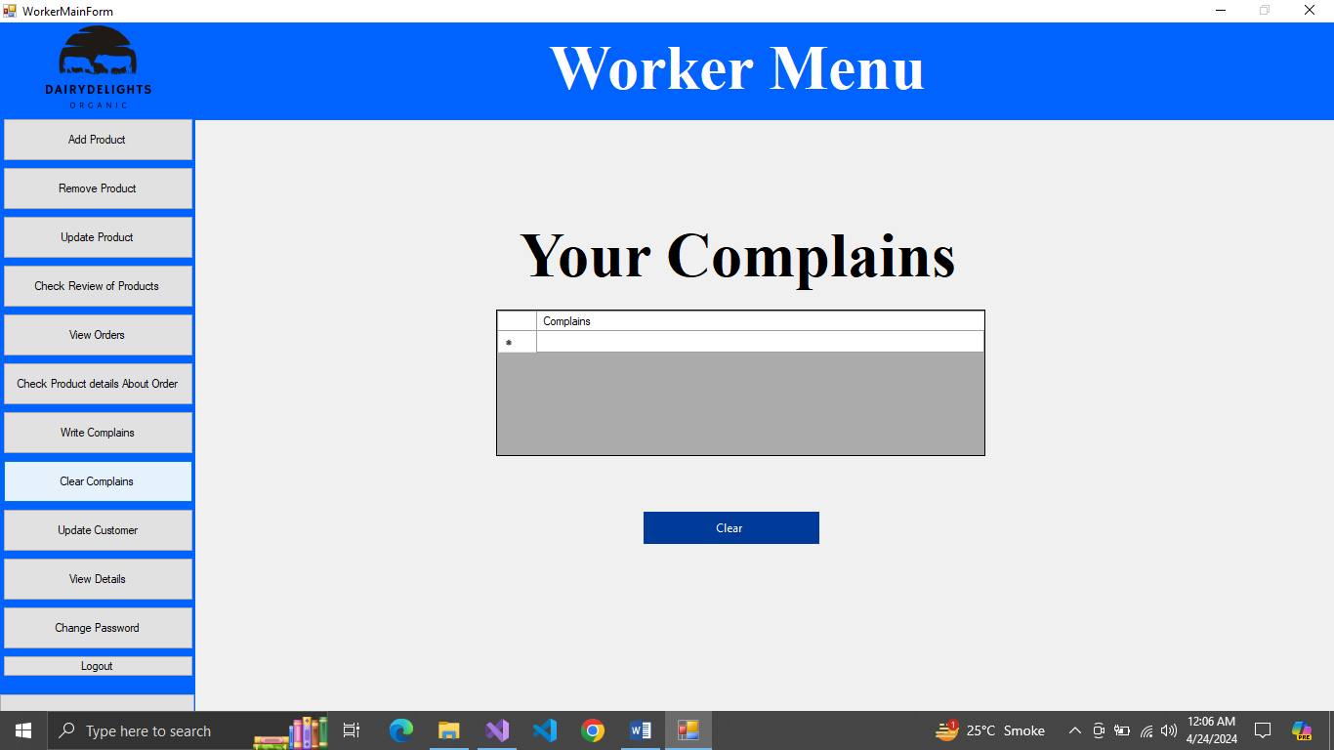

Figure 18view and Delete Complains

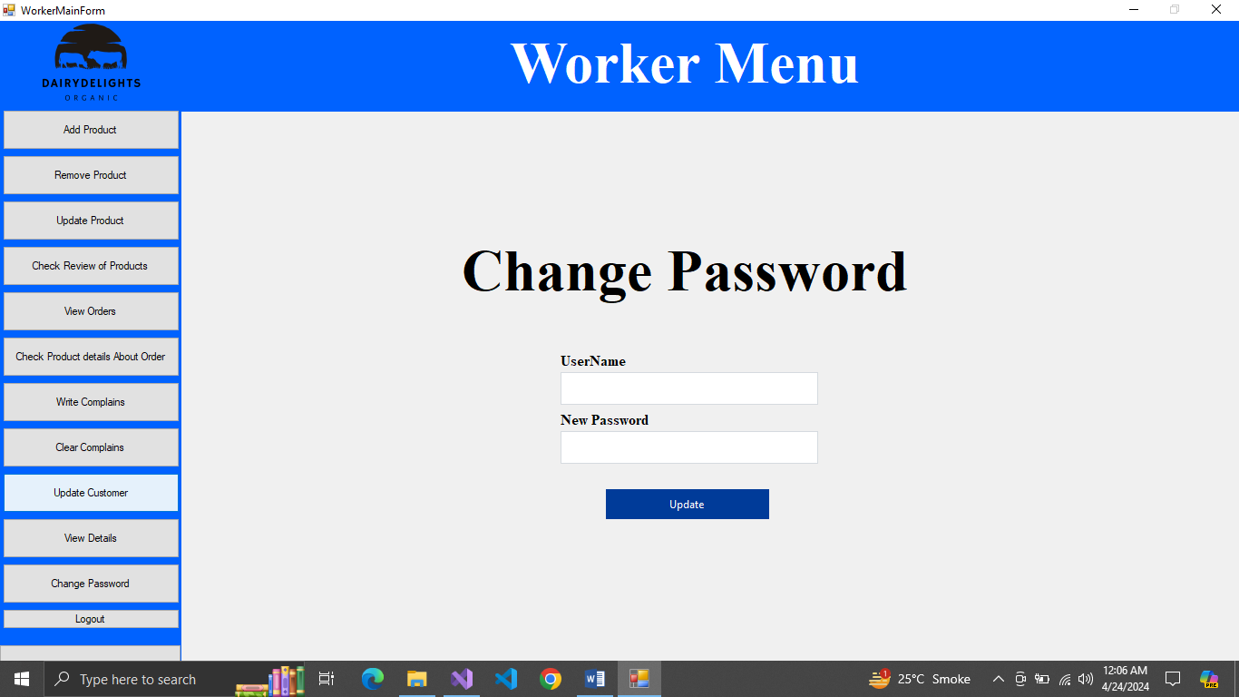

Figure 19Update Customer

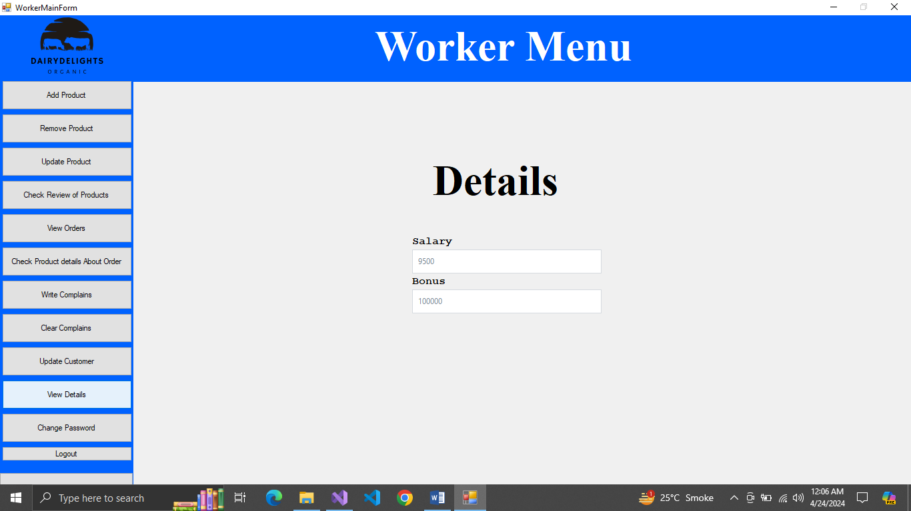

Figure 20View details Worker

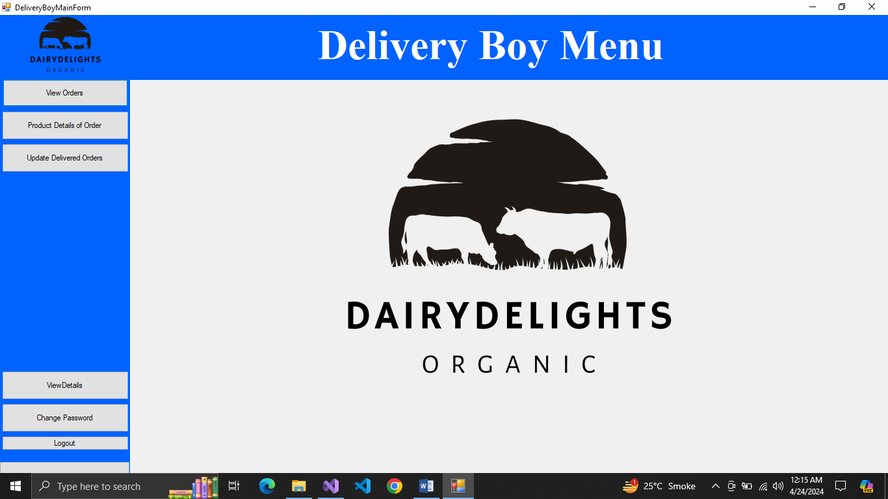

Figure 21Delivery Boy Main Menu

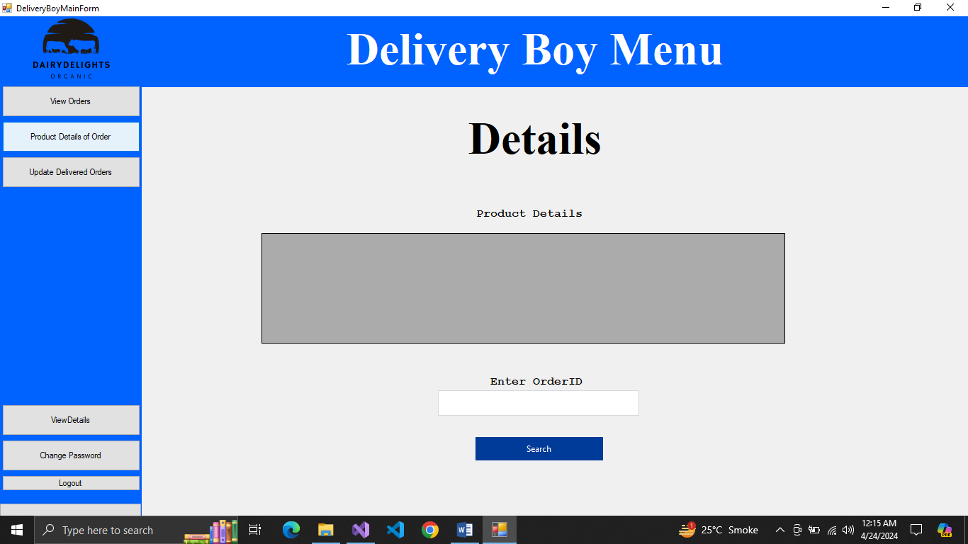

Figure 22View Product details in Order

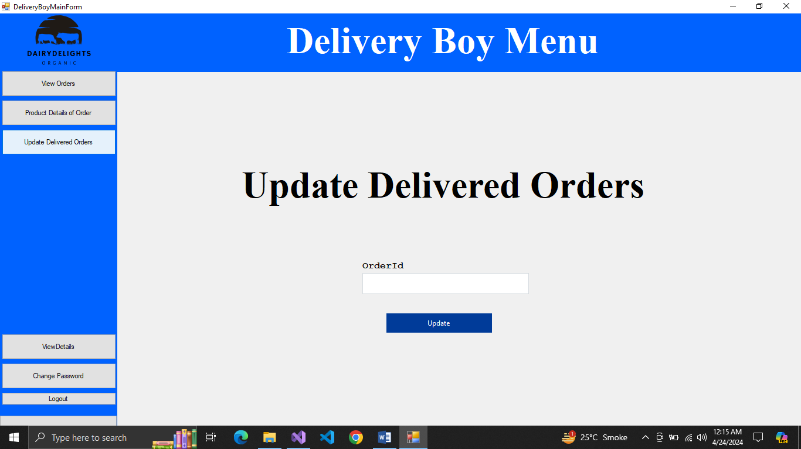

Figure 23Deliver Order

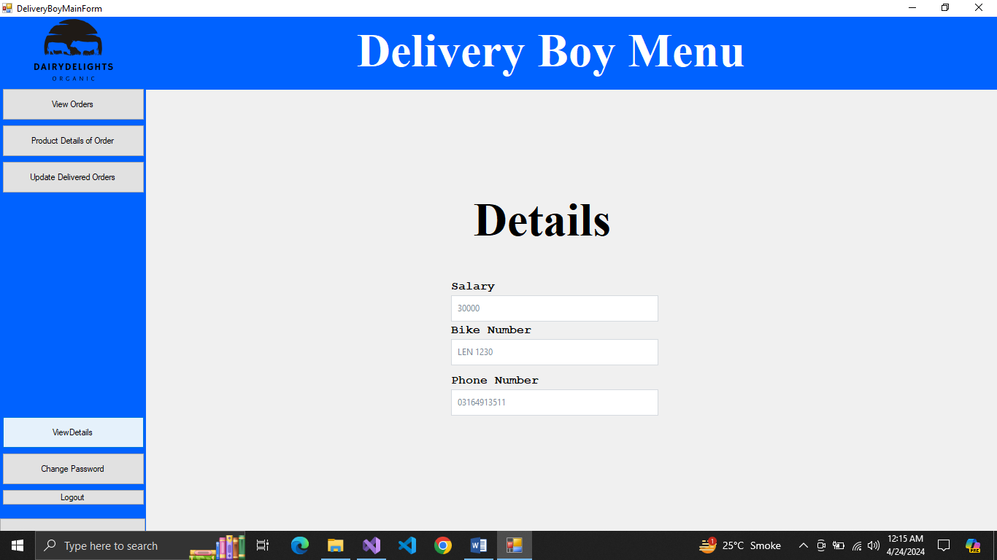

Figure 24View Details Delivery Boy

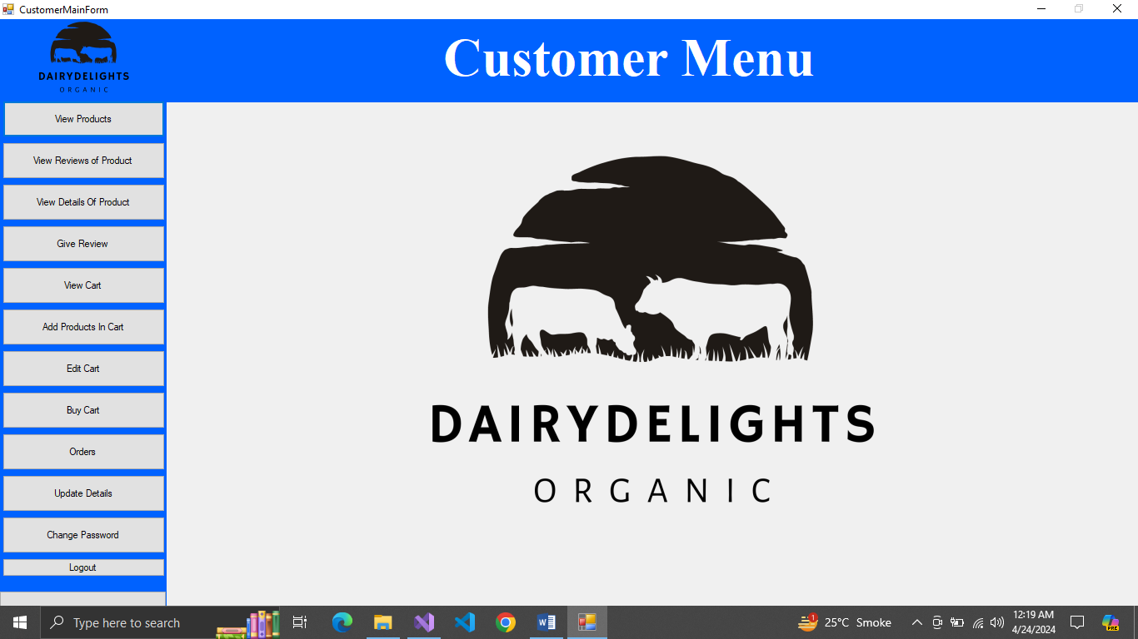

Figure 25Customer Main Page

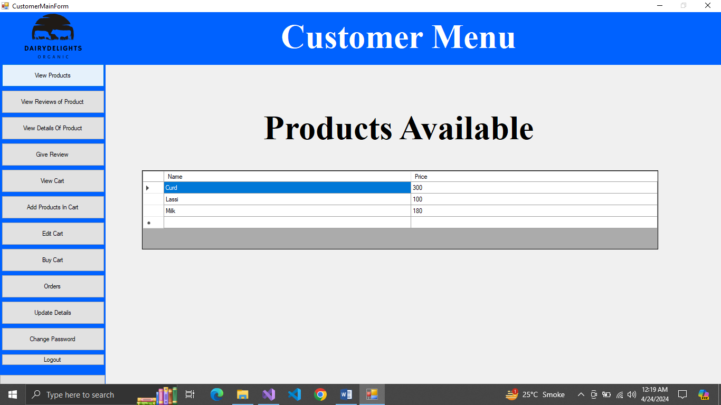

Figure 26View Products Available for Sale

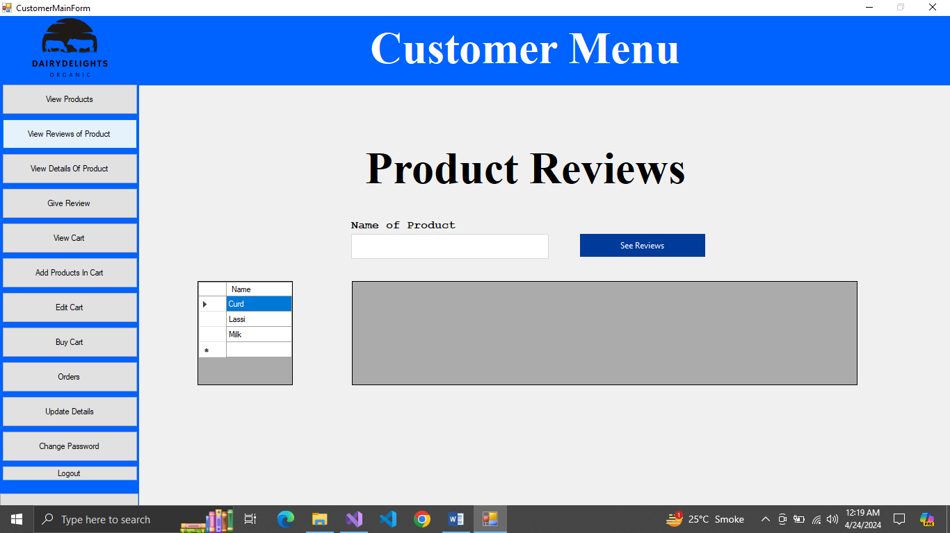

Figure 27View Reviews about Product

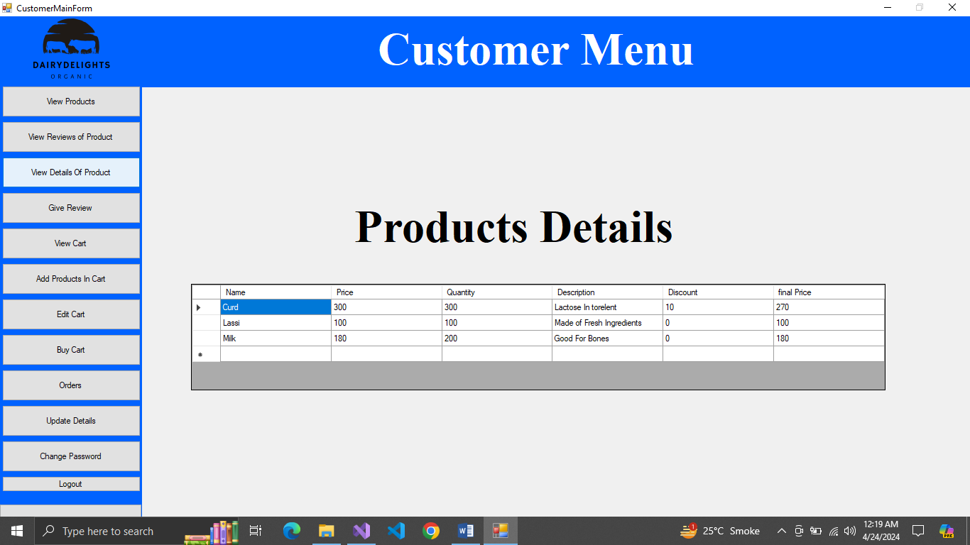

Figure 28View Product Details

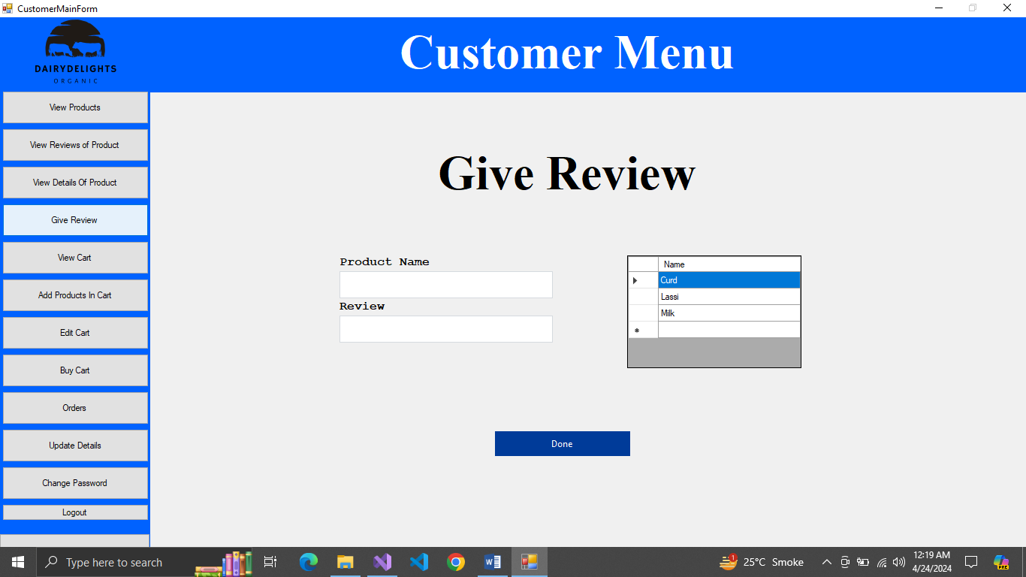

Figure 29Give Review

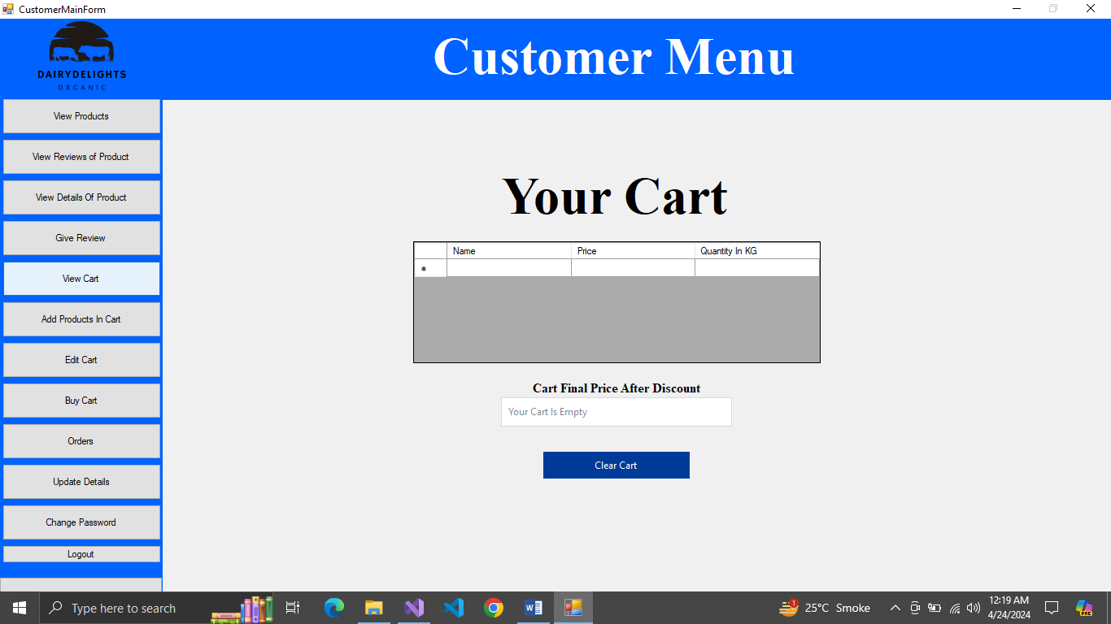

Figure 30View Cart

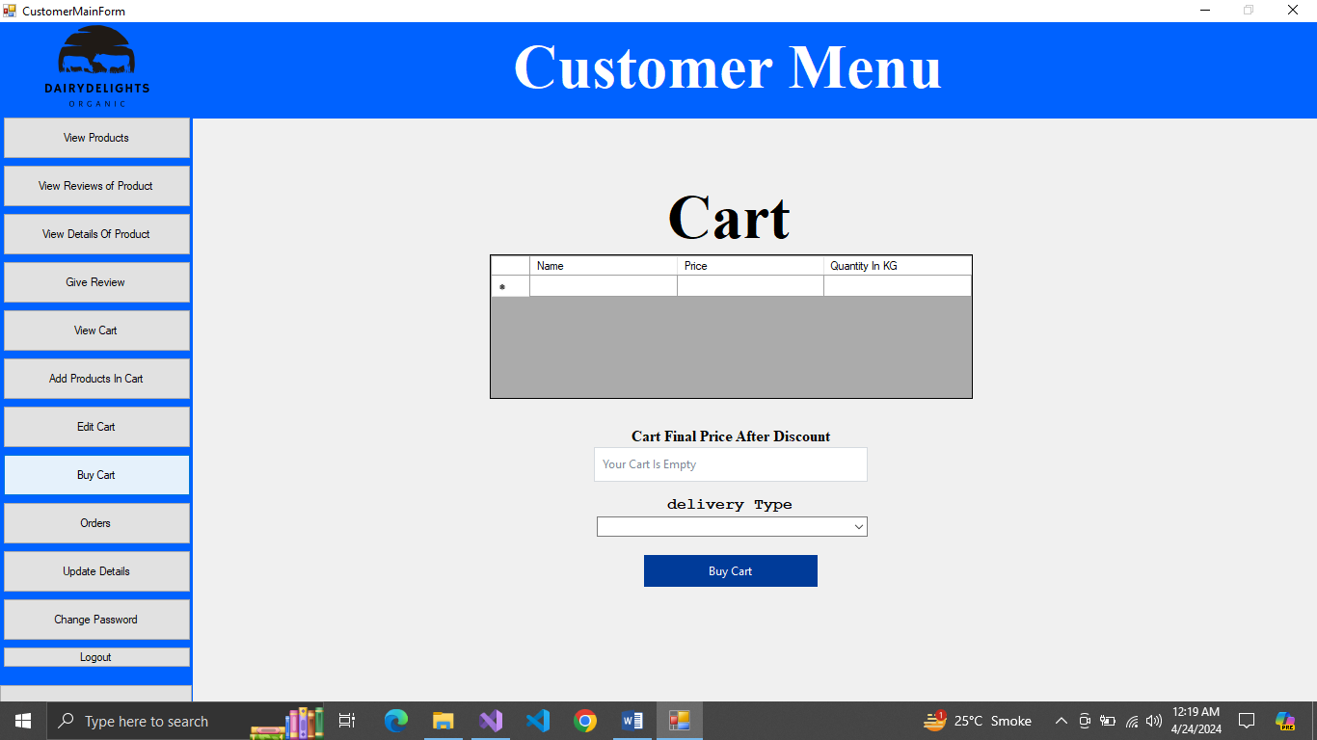

Figure 31Buy Cart

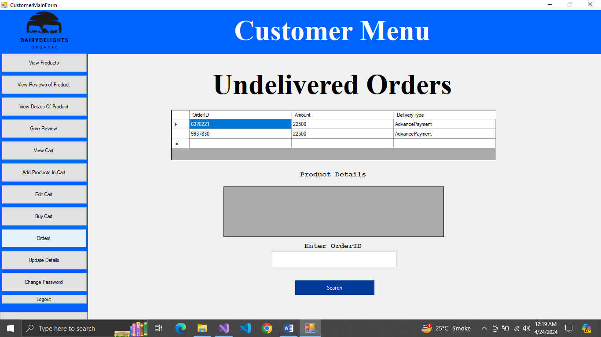

Figure 32View undelivered Orders

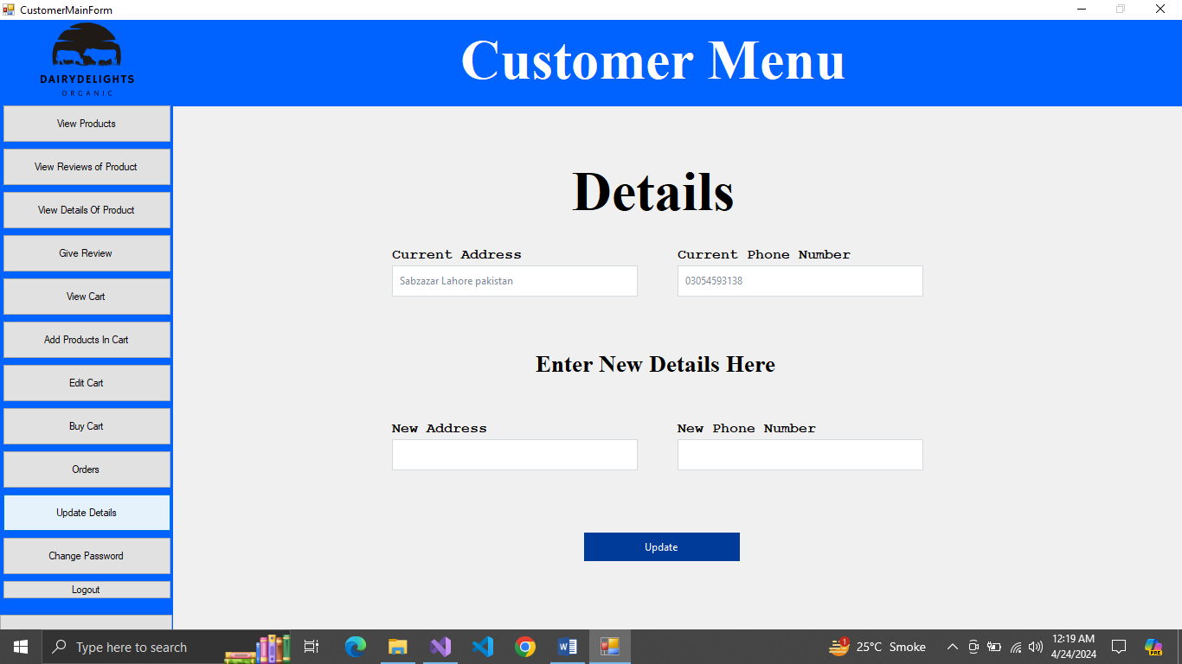

Figure 33Update Customer Details

# CRC

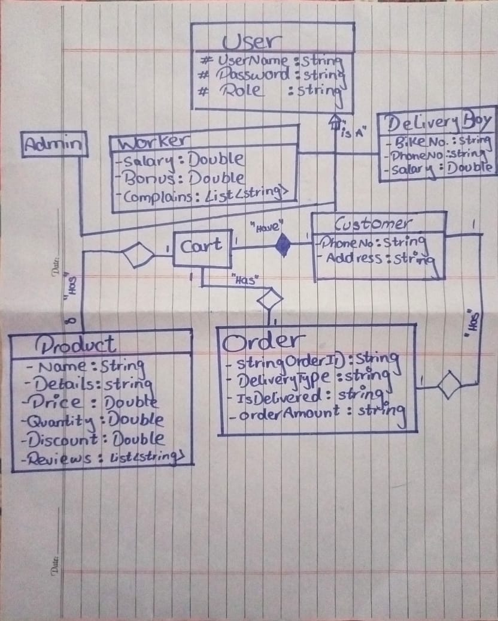

Figure 34CRC

# Complete Code:

UserBL

using System;

using System.Collections.Generic;

using System.Linq;

using System.Text;

using System.Threading.Tasks;

namespace DairyDelightsLibrary.BL

{

public class User

{

protected string UserName, Password, Role; //attribute of the User

public User()

{ }

public User(string username)

{

this.UserName = username;

}

public User(User u) //copy constructor

{

UserName = u.GetUserName();

Password = u.GetPassword();

Role = u.GetRole();

}

public User(string UserName, string Password) //parameterized constructor

{

this.UserName = UserName;

this.Password = Password;

this.Role = "NA";

}

public User(string UserName, string Password, string Role) //parameterized constructor

{

this.UserName = UserName;

this.Password = Password;

this.Role = Role;

}

public string GetRole()

{

return this.Role;

}

public bool SetRole(string Role)

{

this.Role = Role;

return true;

}

public string GetUserName()

{

return this.UserName;

}

public bool SetUserName(string UserName)

{

this.UserName = UserName;

return true;

}

public string GetPassword()

{

return this.Password;

}

public bool SetPassword(string Password)

{

this.Password = Password;

return true;

}

}

}

UserDL With Data Base

using DairyDelightsLibrary.BL;

using DairyDelightsLibrary.Utility;

using DairyDelightsLibrary.Interface;

using System;

using System.Collections.Generic;

using System.Data.SqlClient;

using System.Linq;

using System.Text;

using System.Threading.Tasks;

namespace DairyDelightsLibrary.DL.DataBase

{

public class UserDL :IUser

{

private string ActiveUser;

static UserDL Instance;

private UserDL(string Connection)

{

Utility.Connection.SetConnectionString(Connection);

}

public static UserDL GetInstance(string Connection)

{

if(Instance == null)

{

Instance = new UserDL(Connection);

}

return Instance;

}

public string GetActiveUser()

{

return this.ActiveUser;

}

public bool SignUP(User user)

{

string connectiongString = Connection.GetConnectionString();

SqlConnection connection = new SqlConnection(connectiongString);

connection.Open();

string query = string.Format("Insert into Credentials(Username,Password,Role) Values('{0}', '{1}', '{2}')", user.GetUserName(), user.GetPassword(), user.GetRole());

SqlCommand cmd = new SqlCommand(query, connection);

int rows = cmd.ExecuteNonQuery();

connection.Close();

ActiveUser = user.GetUserName();

if (user.GetRole() == "Customer")

{

connection.Open();

string QueryCustomer = string.Format("Insert into Customer(Username) Values('{0}')", user.GetUserName());

SqlCommand cmdCustomer = new SqlCommand(QueryCustomer, connection); // Corrected variable name

int Rows = cmdCustomer.ExecuteNonQuery(); // Corrected variable name

connection.Close();

}

else if (user.GetRole() == "DeliveryBoy")

{

connection.Open();

string QueryDeliveryBoy = string.Format("Insert into DeliveryBoy(Username) Values('{0}')", user.GetUserName());

SqlCommand cmdDeliveryBoy = new SqlCommand(QueryDeliveryBoy, connection);

int Rows = cmdDeliveryBoy.ExecuteNonQuery();

connection.Close();

}

else if (user.GetRole() == "Worker")

{

connection.Open();

string QueryWorker = string.Format("Insert into Worker(Username) Values('{0}')", user.GetUserName());

SqlCommand cmdWorker = new SqlCommand(QueryWorker, connection);

int Rows = cmdWorker.ExecuteNonQuery();

connection.Close();

}

return true;

}

public bool RemoveUser(string UserName)

{

bool check = false;

string connectiongString = Connection.GetConnectionString();

SqlConnection connection = new SqlConnection(connectiongString);

connection.Open();

string query = string.Format("Delete from Credentials where Username = '{0}'", UserName);

SqlCommand cmd = new SqlCommand(query, connection);

int rows = cmd.ExecuteNonQuery();

connection.Close();

string Role = FindRoleByUserName(UserName);

if (Role == "Customer")

{

connection.Open();

string QueryCustomer = string.Format("Delete from Customer where Username = '{0}'", UserName);

SqlCommand cmdCustmer = new SqlCommand(query, connection);

int Rows = cmd.ExecuteNonQuery();

connection.Close();

}

else if (Role == "DeliveryBoy")

{

connection.Open();

string QueryCustomer = string.Format("Delete from DeliveryBoy where Username = '{0}'", UserName);

SqlCommand cmdCustmer = new SqlCommand(query, connection);

int Rows = cmd.ExecuteNonQuery();

connection.Close();

}

else if (Role == "Worker")

{

connection.Open();

string QueryCustomer = string.Format("Delete from Worker where Username = '{0}'", UserName);

SqlCommand cmdCustmer = new SqlCommand(query, connection);

int Rows = cmd.ExecuteNonQuery();

connection.Close();

}

if (rows > 0)

{

check = true;

}

return check;

}

public string SignIN(string UserName, string Password)

{

string result = "UserNotFound";

string connectiongString = Connection.GetConnectionString();

SqlConnection connection = new SqlConnection(connectiongString);

connection.Open();

string query = string.Format("select Role from Credentials where Username = '{0}' and Password = '{1}' ",UserName,Password);

SqlCommand cmd = new SqlCommand(query, connection);

SqlDataReader reader = cmd.ExecuteReader();

if (reader.Read())

{

result = Convert.ToString(reader["Role"]);

ActiveUser = UserName;

}

return result;

}

public string FindRoleByUserName(string UserName)

{

string result = "";

string connectiongString = Connection.GetConnectionString();

SqlConnection connection = new SqlConnection(connectiongString);

connection.Open();

string query = string.Format("select Role from Credentials where Username = '{0}'",UserName);

SqlCommand cmd = new SqlCommand(query, connection);

SqlDataReader reader = cmd.ExecuteReader();

if (reader.Read())

{

result = Convert.ToString(reader["Role"]);

}

return result;

}

public string FindPasswordByUserName(string UserName)

{

string result = "";

string connectiongString = Connection.GetConnectionString();

SqlConnection connection = new SqlConnection(connectiongString);

connection.Open();

string query = string.Format("select Password from Credentials where Username = '{0}'", UserName);

SqlCommand cmd = new SqlCommand(query, connection);

SqlDataReader reader = cmd.ExecuteReader();

if (reader.Read())

{

result = Convert.ToString(reader["Password"]);

}

return result;

}

public bool CheckIfUserNameAlreadyExist(string UserName)

{

string result = "";

bool check = true;

string connectiongString = Connection.GetConnectionString();

SqlConnection connection = new SqlConnection(connectiongString);

connection.Open();

string query = string.Format("select Role from Credentials where Username = '{0}'", UserName);

SqlCommand cmd = new SqlCommand(query, connection);

SqlDataReader reader = cmd.ExecuteReader();

if (reader.Read())

{

result = Convert.ToString(reader["Role"]);

}

if (result == "")

{

check = false;

}

return check;

}

public bool ChangePassword(string Password)

{

bool Result = false;

string connectiongString = Connection.GetConnectionString();

SqlConnection connection = new SqlConnection(connectiongString);

connection.Open();

string query = string.Format("UPDATE Credentials SET Password = '{0}' WHERE Username = '{1}'", Password, ActiveUser);

SqlCommand cmd = new SqlCommand(query, connection);

int rows = cmd.ExecuteNonQuery();

connection.Close();

if(rows > 0)

{

Result = true;

}

return Result;

}

public bool ChangePasswordByUserName(string Username,string Password)

{

bool Result = false;

string connectiongString = Connection.GetConnectionString();

SqlConnection connection = new SqlConnection(connectiongString);

connection.Open();

string query = string.Format("UPDATE Credentials SET Password = '{0}' WHERE Username = '{1}'", Password, Username);

SqlCommand cmd = new SqlCommand(query, connection);

int rows = cmd.ExecuteNonQuery();

connection.Close();

if (rows > 0)

{

Result = true;

}

return Result;

}

public List<User> GetUsersList()

{

List<User> users = new List<User>();

string connectiongString = Connection.GetConnectionString();

SqlConnection connection = new SqlConnection(connectiongString);

connection.Open();

string Query = string.Format("select * from Credentials");

SqlCommand Command = new SqlCommand(Query, connection);

SqlDataReader reader = Command.ExecuteReader();

while (reader.Read())

{

string username = Convert.ToString(reader["Username"]);

string password = Convert.ToString(reader["Password"]);

string role = Convert.ToString(reader["Role"]);

User user = new User(username, password, role); //object is made

users.Add(user);

}

connection.Close();

return users;

}

}

}

User DL with file FileHandling

using DairyDelightsLibrary.BL;

using DairyDelightsLibrary.Interface;

using System;

using System.Collections.Generic;

using System.Data;

using System.IO;

using System.Threading;

namespace DairyDelightsLibrary.DL.FileHandling

{

public class UserDL : IUser

{

public static string ActiveUser;

static UserDL Instance;

public List<User> UsersList = new List<User>();

private UserDL(string path)

{

Utility.Path.SetUserFilePath(path);

UsersList = GetDataFromUserFile(path);

}

public static UserDL GetInstance(string path)

{

if (Instance == null)

{

Instance = new UserDL(path);

}

return Instance;

}

public string SignIN(string UserName, string Password)

{

foreach (User user in UsersList)

{

if (UserName == user.GetUserName() && Password == user.GetPassword())

{

ActiveUser = UserName;

return user.GetRole();

}

}

return "UserNotFound";

}

public bool SignUP(User user)

{

UsersList.Add(user);

ActiveUser = user.GetUserName();

StoreDetailsOfUser();

return true;

}

public string GetActiveUser()

{

return ActiveUser;

}

public bool ChangePassword(string Password)

{

foreach (User user in UsersList)

{

if (ActiveUser == user.GetUserName())

{

bool check = user.SetRole(Password);

StoreDetailsOfUser();

return check;

}

}

return false;

}

public bool ChangePasswordByUserName(string Username, string Password)

{

foreach (User user in UsersList)

{

if (Username == user.GetUserName())

{

bool check = user.SetRole(Password);

return check;

}

}

return false;

}

public bool CheckIfUserNameAlreadyExist(string UserName)

{

if(UsersList == null)

{

return false;

}

foreach (User user in UsersList)

{

if (UserName == user.GetUserName())

{

return true;

}

}

return false;

}

public string FindPasswordByUserName(string UserName)

{

foreach (User user in UsersList)

{

if (UserName == user.GetUserName())

{

return user.GetPassword();

}

}

return "";

}

public string FindRoleByUserName(string UserName)

{

foreach (User user in UsersList)

{

if (UserName == user.GetUserName())

{

return user.GetRole();

}

}

return "";

}

public List<User> GetUsersList()

{

return this.UsersList;

}

public bool RemoveUser(string UserName)

{

foreach (User user in UsersList)

{

if (UserName == user.GetUserName())

{

UsersList.Remove(user);

StoreDetailsOfUser();

return true;

}

}

return false;

}

private string parseData(string record, int field)

{

int comma = 1;

string item = "";

for (int x = 0; x < record.Length; x++)

{

if (record[x] == '%')

{

comma++;

}

else if (comma == field)

{

item = item + record[x];

}

}

return item;

}

private List<User> GetDataFromUserFile(string path)

{

List<User> users = new List<User>();

if (File.Exists(path))

{

StreamReader fileVariable = new StreamReader(path);

string record;

while ((record = fileVariable.ReadLine()) != null)

{

string userName = parseData(record, 1);

string userPassword = parseData(record, 2);

string userRole = parseData(record, 3);

User user = new User(userName, userPassword, userRole);

users.Add(user);

}

fileVariable.Close();

}

return users;

}

private void StoreDetailsOfUser()

{

string path = Utility.Path.GetUserFilePath();

StreamWriter file = new StreamWriter(path, append :false);

for (int i = 0; i < UsersList.Count; i++)

{

User user1 = UsersList[i];

file.WriteLine($"{user1.GetUserName()}%{user1.GetPassword()}%{user1.GetRole()}%");

}

file.Flush();

file.Close();

}

}

}

UserUI

using DairyDelightsLibrary.BL;

using DairyDelightsLibrary.Validation;

using System;

using System.Data;

using System.Security.Cryptography;

namespace ConsoleAppProject.UI.Menu

{

internal class GetInformationMenus

{

public static string MainMenu()

{

Console.Clear();

string option = "5";

Console.WriteLine("Welcome");

Console.WriteLine("1. Sign In");

Console.WriteLine("2.sign Up");

Console.WriteLine("3. Exit");

Console.Write("Enter Your Option : ");

option = Console.ReadLine();

return option;

}

public static User SignIN()

{

Console.Clear();

Console.Write("Enter UserName : ");

string username = Console.ReadLine();

Console.Write("Enter Password : ");

string password = Console.ReadLine();

User user = new User(username, password);

return user;

}

public static User SignUp()

{

Console.Clear();

Console.Write("Enter UserName : ");

string username = Console.ReadLine();

Console.Write("Enter Password : ");

string password = Console.ReadLine();

string role = "Customer";

if (username != "" && password != "")

{

if (UserValidation.IsStringValid(username) && UserValidation.IsStringValid(password))

{

User user = new User(username, password, role);

return user;

}

}

return null;

}

public static string AdminMenu()

{

Console.Clear();

string option;

Console.WriteLine(" ************************************************************ Admin Menu ************************************************************");

Console.WriteLine();

Console.WriteLine("1. Add New Employee");

Console.WriteLine("2. Remove Employee");

Console.WriteLine("3. Change Others Password");

Console.WriteLine("4. Update Password");

Console.WriteLine("5. Logout");

Console.Write("Enter Your Option Here: ");

option = Console.ReadLine();

return option;

}

public static User AddUser()

{

Console.Clear();

Console.Write("Enter UserName : ");

string username = Console.ReadLine();

Console.Write("Enter Password : ");

string password = Console.ReadLine();

Console.Write("Enter Role (Worker or DeliveryBoy): ");

string role = Console.ReadLine();

if (username != "" && password != "" && role != "")

{

if (UserValidation.IsStringValid(username) && UserValidation.IsStringValid(password))

{

if(role == "Worker" ||role == "DeliveryBoy")

{

User user = new User(username, password, role);

return user;

}

}

}

return null;

}

public static void DisplayAllUsersOnScreen(List<User> users)

{

foreach(User user in users)

{

Console.WriteLine("UserName = " + user.GetUserName() + ", Password = " + user.GetPassword() + ", Role = " + user.GetRole());

}

}

public static string EnterUserName()

{

Console.Write("Enter UserName: ");

string id = Console.ReadLine();

return id;

}

public static string EnterPassword()

{

Console.Write("Enter Password: ");

string Password = Console.ReadLine();

return Password;

}

public static string EnterNewPassword()

{

Console.Write("Enter New Password: ");

string Password = Console.ReadLine();

return Password;

}

public static string EnterRole()

{

Console.Write("Enter Role (Worker or DeliveryBoy): ");

string Role = Console.ReadLine();

return Role;

}

public static void ClearScreen()

{

Console.Clear();

}

public static void Successfull()

{

Console.WriteLine("Operation Successfull :)");

Console.ReadKey();

}

public static void Unsuccessfull()

{

Console.WriteLine("Operation Unsuccessfull :)");

Console.ReadKey();

}

}

}

ObjectHandler

using DairyDelightsLibrary.Interface;

using System;

using System.Collections.Generic;

using System.Linq;

using System.Text;

using System.Threading.Tasks;

using DairyDelightsLibrary.BL;

using DairyDelightsLibrary.Validation;

using System.IO;

using DairyDelightsLibrary.Utility;

using DairyDelightsLibrary.DL.DataBase;

//using DairyDelightsLibrary.DL.FileHandling;

namespace ConsoleAppProject

{

public class ObjectHandler

{

static string path = "UserDetails.txt";

static string Connection = "Data Source=MALIK;Initial Catalog=Final_Project;Integrated Security=True;";

public static IUser GetUserInstance()

{

//IUser user = UserDL.GetInstance(path);

IUser user = UserDL.GetInstance(Connection);

return user;

}

}

}

Driver Program

using DairyDelightsLibrary.BL;

using DairyDelightsLibrary.Interface;

using DairyDelightsLibrary.Validation;

using System;

namespace ConsoleAppProject

{

internal class Program

{

static void Main(string[] args)

{

IUser user = ObjectHandler.GetUserInstance();

while (true)

{

string option = UI.Menu.GetInformationMenus.MainMenu();

if (option == "1")

{

User OldUser = UI.Menu.GetInformationMenus.SignIN();

string Role = user.SignIN(OldUser.GetUserName(), OldUser.GetPassword());

if (Role == "Admin")

{

while (true)

{

string AdminOption = UI.Menu.AdminMenuUI.AdminMenu();

if (AdminOption == "1")

{

User NewEmployee = UI.Menu.AdminMenuUI.AddUser();

if(NewEmployee != null)

{

bool check = user.SignUP(NewEmployee);

if (check)

{

UI.Menu.GetInformationMenus.Successfull();

continue;

}

}

else

{

UI.Menu.GetInformationMenus.Unsuccessfull();

continue;

}

}

else if (AdminOption == "2")

{

UI.Menu.AdminMenuUI.DisplayAllUsersOnScreen(user.GetUsersList());

string UserName = UI.Menu.GetInformationMenus.EnterUserName();

if(user.CheckIfUserNameAlreadyExist(UserName))

{

bool check = user.RemoveUser(UserName);

if (check)

{

UI.Menu.GetInformationMenus.Successfull();

continue;

}

}

else

{

UI.Menu.GetInformationMenus.Unsuccessfull();

continue;

}

}

else if (AdminOption == "3")

{

UI.Menu.AdminMenuUI.DisplayAllUsersOnScreen(user.GetUsersList());

string UserName = UI.Menu.GetInformationMenus.EnterUserName();

string NewPassword = UI.Menu.GetInformationMenus.EnterNewPassword();

if (user.CheckIfUserNameAlreadyExist(UserName))

{

bool check = user.ChangePasswordByUserName(UserName, NewPassword);

if (check)

{

UI.Menu.GetInformationMenus.Successfull();

continue;

}

}

else

{

UI.Menu.GetInformationMenus.Unsuccessfull();

continue;

}

}

else if (AdminOption == "4")

{

string NewPassword = UI.Menu.GetInformationMenus.EnterNewPassword();

if(UserValidation.IsStringValid(NewPassword))

{

bool check = user.ChangePassword(NewPassword);

if (check)

{

UI.Menu.GetInformationMenus.Successfull();

continue;

}

}

else

{

UI.Menu.GetInformationMenus.Unsuccessfull();

continue;

}

}

else if (AdminOption == "5")

{

break;

}

else

{

continue;

}

}

}

else if (Role == "Worker")

{

while (true)

{

string optionworker = UI.Menu.WorkerMenuUI.WorkerMenu();

if(optionworker == "1")

{

string NewPassword = UI.Menu.GetInformationMenus.EnterNewPassword();

if (UserValidation.IsStringValid(NewPassword))

{

bool check = user.ChangePassword(NewPassword);

if (check)

{

UI.Menu.GetInformationMenus.Successfull();

continue;

}

}

else

{

UI.Menu.GetInformationMenus.Unsuccessfull();

continue;

}

}

else if(optionworker == "2")

{

break;

}

else

{

continue;

}

}

}

else if (Role == "Delivery Boy")

{

while (true)

{

string optionWorker = UI.Menu.DeliveryBoyMenuUI.DeliveryBoyMenu();

if (optionWorker == "1")

{

string NewPassword = UI.Menu.GetInformationMenus.EnterNewPassword();

if (UserValidation.IsStringValid(NewPassword))

{

bool check = user.ChangePassword(NewPassword);

if (check)

{

UI.Menu.GetInformationMenus.Successfull();

continue;

}

}

else

{

UI.Menu.GetInformationMenus.Unsuccessfull();

continue;

}

}

else if (optionWorker == "2")

{

break;

}

else

{

continue;

}

}

}

else if (Role == "Customer")

{

while (true)

{

string optionCustomer = UI.Menu.CustomerMenuUI.CustomerMenu();

if (optionCustomer == "1")

{

string NewPassword = UI.Menu.GetInformationMenus.EnterNewPassword();

if (UserValidation.IsStringValid(NewPassword))

{

bool check = user.ChangePassword(NewPassword);

if (check)

{

UI.Menu.GetInformationMenus.Successfull();

continue;

}

}

else

{

UI.Menu.GetInformationMenus.Unsuccessfull();

continue;

}

}

else if (optionCustomer == "2")

{

break;

}

else

{

continue;

}

}

}

else

{

UI.Menu.GetInformationMenus.Unsuccessfull();

continue;

}

}

else if (option == "2")

{

User NewUser = UI.Menu.GetInformationMenus.SignUp();

if (NewUser != null)

{

bool check = user.SignUP(NewUser);

if (check)

{

UI.Menu.GetInformationMenus.Successfull();

}

}

else

{

UI.Menu.GetInformationMenus.Unsuccessfull();

continue;

}

}

else if (option == "3")

{

break;

}

else

{

continue;

}

}

}

}

}

# Weakness in Project:

* 1. The Delivery system is not Good the Customer do not know when will his order arrive and do not know anyone to contact for order
  2. There is no module of Refund if wrong order delivered
  3. Console App project is for just User not for other entities
  4. Window Forms are not Responsive
  5. Data base is not Normalize and one cell has more than one data

# Future Directions

* 1. There will be a lot imprudent in which user will know who will deliver his order and when and he can also call him to comfit
  2. There will be Refund method in which you will get refund of order
  3. Console App and Windows Form Complete
  4. Data Layer complete with Data Base and file handling so Front-End Developer can use what he like
  5. Normalization of Data Base